Example – Maternity Bundle claim on 835

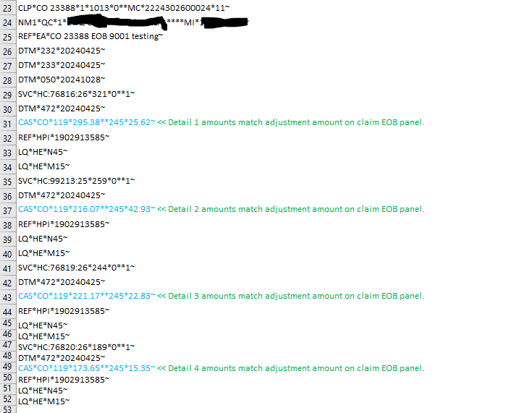

Example – paper RA of $0 claim paid
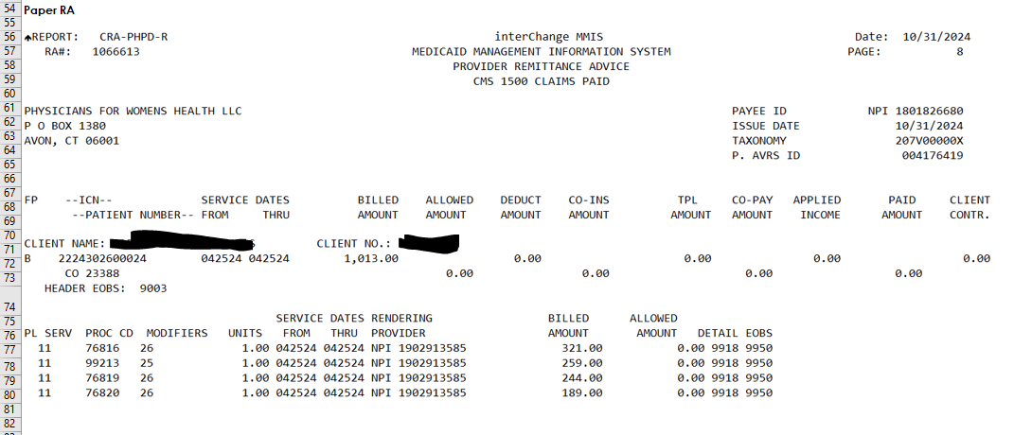

Example of paper RA with case rate payments

