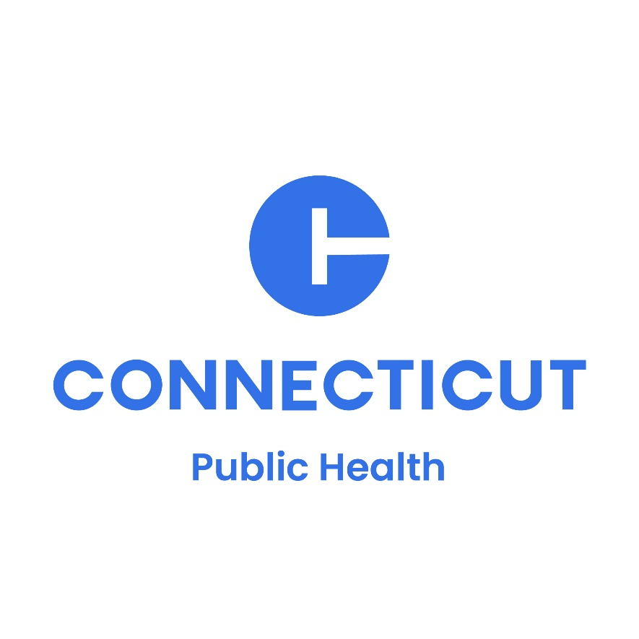
HURRICANE PREPAREDNESS

Toolkit for Local Health Departments

September 2024

Table of Contents
Contents
Understanding Hurricane Risks 3
Resources and Tools 5
Hurricane Advisory 6
Social Media & Graphics 9
Web Content 27
Hurricane Safety for Vulnerable Populations 27
Hurricane Events: Stay Safe and Prepared 29
Fact Sheets…………………………………………………………………………………………………………..………..31
Additional Resources 32

Understanding Hurricane Risks
Hurricanes pose significant public health risks, particularly as climate change contributes to more frequent, intense, and prolonged storms. These conditions can lead to serious health issues, property damage, and disruptions in daily life with vulnerable populations being especially at risk. Effective risk communication is essential to mitigate these dangers, ensuring that communities are informed, prepared, and able to take protective actions.
Hurricanes are large, powerful storm systems characterized by strong winds, heavy rainfall, and storm surges. The Atlantic hurricane season lasts from June to November. Hurricanes can result in flooding, wind damage, and widespread power outages, leading to a range of health and safety hazards. Vulnerable groups including the elderly, children, individuals with pre-existing health conditions, and those in low-income areas or without access to safe shelter, are particularly susceptible to the adverse effects of hurricanes.
Southern New England locations, such as Connecticut, are subject to all three of the following hurricane threats:
- Coastal flooding due to the storm surge
- Widespread wind damage
- Widespread inland small stream and river flooding due to heavy rains
The strongest hurricanes, such as the great New England hurricane of 1938, and Hurricanes Carol and Sandy, brought severe damage to coastal locations. They also disrupted utility power for days across the interior due to downed trees and high winds. Stronger hurricanes, as well as many of the weaker tropical storms, have caused inland river flooding in parts of New England.
Effective Hurricane Risk Communications
Risk communication involves delivering timely, clear, and actionable information to the public about potential hazards and safety measures. Effective communication can significantly reduce the health impacts of hurricanes by promoting awareness and encouraging preventive actions. These communications include providing information on recognizing warning signs, advising on ways to prepare and stay safe, and alerting communities to the availability of shelters and other resources. Here are some key components of effective risk communications:
Targeted Messaging: Develop messages tailored to different audiences, especially vulnerable populations. Targeted messaging ensures that the information is relevant and accessible to those at highest risk.
- Multi-Channel Dissemination: Utilize various communication channels such as social media, local news, community bulletin boards, and direct outreach to maximize reach and engagement.
- Clear and Concise Information: Ensure that messages are easy to understand, avoiding technical jargon, and providing straightforward advice on actions to take before, during, and after hurricanes.
- Timely Updates: Provide regular updates as storm conditions change, ensuring that the public receives the most current information to make informed decisions.
- Community Engagement: Engage with community leaders and organizations to help spread the message and support local outreach efforts.

Resources and Tools
This toolkit includes:
- A template Press Release for community education on hurricane safety
- Template social media messages and graphics for hurricane warning and resource sharing
- Guidance on addressing At-Risk and Vulnerable Populations during hurricanes
- Messages available in the following languages:
  - Chinese
  - English
  - French
  - Italian
  - Kreyol
  - Polish
  - Portuguese
  - Russian
  - Spanish
  - Vietnamese
- Additional hurricane resources and guidance are available at Ready.gov, CDC and the Red Cross webpages. For example, LHDs can use this dashboard from NOAA (National Hurricane Center (noaa.gov) to explore their community’s risk for hurricane and assets that can protect people during hurricanes
Using these resources will help ensure that communities are well-informed and protected during hurricane events. Health officials should familiarize themselves with these tools and integrate them into their communication plans to effectively manage the health risks associated with hurricane.

INSERT LHD LOGO
TEMPLATE PRESS RELEASE

Hurricane Advisory
With a hurricane forecast on the horizon, [Name of LHD] urges residents to take necessary precautions.
[Insert quote on hurricane preparedness, which offers suggestions for residents by Director of Health.]
Example: “It’s never too early to make sure you and your family are prepared for natural disasters, especially hurricanes,” said [Director of Health].
Residents should have an emergency plan, secure their homes, and ensure they have necessary supplies such as water, non-perishable food, medications, and important documents. Evacuate if instructed and stay informed through local news and weather updates.”
Anyone experiencing health issues during a hurricane should seek medical assistance immediately. Although anyone can be affected by a hurricane, certain groups are at particularly high risk, including:
- Older individuals who have a higher risk of dehydration and health complications from power outages
- Individuals with chronic conditions that are vulnerable to power outages affecting medical devices, support services and refrigeration for medications
- Low-Income Households that are high risk for evacuations due to living in areas prone to flooding or storm damage.
Follow the steps below to stay safe during a hurricane:
Review Emergency Supplies
Be sure to have the following supplies on hand before the storm:

- One gallon of water per person per day for at least three days, for drinking and sanitation
- A three-day supply of non-perishable food
- Battery-powered or hand crank radio, and a National Oceanic and Atmospheric Administration (NOAA) weather radio with tone alert and extra batteries for both
- Flashlight and extra batteries
- First aid kit
- A whistle to signal for help
- Wrench or pliers to turn off utilities
- Local maps
- Cell phone with chargers, inverter or solar charger.

Family Emergency Plan
- Identify an out-of-town contact. It may be easier to make a long-distance phone call than to call across town, so an out-of-town contact may be in a better position to communicate among separated family members.
- Be sure every member of your family knows the phone number and can call the emergency contact. If you have a cell phone, program that person(s) as "ICE" (In Case of Emergency) in your phone. If you are in an accident, emergency personnel will often check your ICE listings in order to get a hold of someone you know. Make sure to tell your family and friends that you've listed them as emergency contacts.
- Teach family members how to use text messaging. Text messages can often get around network disruptions when a phone call might not be able to get through.
- Subscribe to alert services. Many communities/states now have systems that will send instant text alerts or e-mails to let you know about bad weather, road closings, local emergencies, etc. In Connecticut, go to www.ct.gov/ctalert to register for alerts.
During and After the Hurricane
The storm might be over, but that doesn’t mean the danger has passed. Keep yourself and loved ones safe by following these safety tips:
Flooding / Private Wells
- Do not play, bathe or drive in flood waters. There may be unknown contaminants such as sewage or chemicals. Cars also will not protect you from the flooding and can be swept away.
- Flooded wells should be considered contaminated and disinfected before homeowners resume using them.
- If you notice any unusual changes to the water (color, taste or odor), use bottled water for drinking and cooking until water testing is done.
- For more information on flood clean up, well and sewage safety, visit the CT DPH page on Flooding.
Power Outage
- Keep the fridge and freezer doors closed to keep it cool for as long as possible.
- Food or medication in the fridge or freezer may be unsafe to consume if the power has been out for 4 hours or more, or if the inside temperature is above 45 degrees Fahrenheit.
- If a life depends on a refrigerated drug, try to keep the medication as cool as possible. Only use the medication until a new supply is available.

Carbon Monoxide
- Make sure to place any generators far enough away from your home, so that fumes to do not enter your home
- Carbon monoxide (CO) is a poisonous gas, that you cannot see or smell, and can cause sudden illness and death Symptoms may resemble the flu (i.e. headache, tiredness, dizziness, upset stomach, nausea, vomiting, chest pain, and confusion).
- Carbon monoxide gas forms when fuels like gasoline, propane, etc. do not burn up completely. Common sources include portable generators, gas powered heaters, gas or oil furnaces, charcoal grills used indoors, gas appliances and motor vehicle exhaust.
- Visit the CT DPH webpage on Power Outages and CO for more information

For more information about hurricane preparedness, visit the DPH Hurricane webpage at www.ct.gov/dph/hurricanes.

###

Social Media & Graphics

Social Media: The following pages contain social media posts in multiple languages for LHDs to select and use on their social media platforms.

ENGLISH:
Don't wait until the last minute! Start preparing for hurricane season now. Review evacuation routes, secure important documents, and ensure you have enough supplies. #BePrepared #HurricaneSeason
SPANISH:
No esperes hasta el último minuto. Prepárate para la temporada de huracanes ya. Revisa las rutas de evacuación, asegura documentos importantes y asegúrate que tienes suminitros suficientes. #BePrepared #HurricaneSeason
CHINESE:
不要等到最后一刻！立即开始为飓风季节做准备。检查疏散路线、妥善保存重要文件，并确保你有足够的物资。#BePrepared #HurricaneSeason
PORTUGUESE:
Não espere até ao último minuto. Comece já a preparar-se para a época de furacões. Reveja as rotas de evacuação, proteja documentos importantes e certifique-se de ter abastecimentos suficientes. #BePrepared #HurricaneSeason
VIETNAMESE:
Đừng chờ đến phút chót! Bắt đầu chuẩn bị cho mùa bão ngay từ bây giờ. Xem lại các tuyến đường di tản, bảo quản kỹ giấy tờ quan trọng và đảm bảo có đủ vật tư. #BePrepared #HurricaneSeason
POLISH:
Nie czekaj do ostatniej chwili! Już teraz rozpocznij przygotowania do sezonu huraganowego. Sprawdź drogi ewakuacyjne, zabezpiecz ważne dokumenty i upewnij się, że masz wystarczającą ilość zapasów. #BePrepared #HurricaneSeason
RUSSIAN:
Не откладывайте на последний момент! Начните готовиться к сезону ураганов прямо сейчас. Изучите маршруты эвакуации, подготовьте важные документы и убедитесь, что у вас достаточно запасов. #BePrepared #HurricaneSeason
CREOLE:
Pa rete tann jiskas dènye minit! Kòmanse prepare w pou sezon siklòn kounye a. Revize chemen evakyasyon yo, sekirize dokiman enpòtan yo, epi asire w ke ou gen ase pwovizyon. #BePrepared #HurricaneSeason
FRENCH:
N’attendez pas la dernière minute ! Préparez-vous dès maintenant à la saison des ouragans. Passez en revue les itinéraires d’évacuation, mettez vos documents importants en lieu sûr et assurez-vous d’avoir suffisamment de provisions. #BePrepared #HurricaneSeason
ITALIAN:
Non aspettare fino all'ultimo minuto! Inizia subito a prepararti per la stagione degli uragani. Rivedi i percorsi di evacuazione, metti al sicuro i documenti importanti e assicurati di avere abbastanza provviste. #BePrepared #HurricaneSeason
ARABIC:
لا تنتظر حتى اللحظة الأخيرة! ابدأ الاستعداد لموسم الأعاصير الآن. راجع طرق الإخلاء، واحرص على تأمين الوثائق المهمة، مع ضمان أن يكون لديك ما يكفي من الإمدادات.

ENGLISH:
Stay informed! Follow local weather updates and emergency alerts. Being knowledgeable can save your life during hurricane season. #StayInformed #LocalNews
SPANISH:
Infórmate siempre. Sigue las noticias locales del clima y las alertas de emergencia. Estar informado puede salvar tu vida durante la temporada de huracanes. #StayInformed #LocalNews
CHINESE:
保持消息灵通！关注当地天气更新和紧急通知。在飓风季节，掌握信息可以挽救您的生命。$StayInformed #LocalNews
PORTUGUESE:
Mantenha-se informado! Siga as atualizações meteorológicas locais e alertas de emergência. Ter conhecimento pode salvar a sua vida durante a época de furacões. #StayInformed #LocalNews
VIETNAMESE:
Luôn theo dõi và cập nhật tình hình! Theo dõi thông tin cập nhật về thời tiết và cảnh báo khẩn cấp của địa phương. Hiểu biết có thể giúp cứu tính mạng trong mùa bão. #StayInformed #LocalNews
POLISH:
Bądź na bieżąco! Śledź lokalne aktualizacje pogodowe i powiadomienia o sytuacjach awaryjnych. Informacja może uratować Ci życie podczas sezonu huraganowego. #StayInformed #LocalNews
RUSSIAN:
Следите за новостями! Следите за новостями о погоде и экстренными оповещениями. Осведомленность о ситуации может спасти вам жизнь во время сезона ураганов. #StayInformed #LocalNews
CREOLE:
Rete enfòme! Swiv mizajou sou move tan lokal yo ak alèt ijans yo. Lè w gen konesans, sa ka sove lavi w pandan sezon siklòn nan. #StayInformed #LocalNews
FRENCH:
Restez informé ! Suivez les mises à jour météorologiques locales et les alertes d’urgence. Être bien informé peut vous sauver la vie pendant la saison des ouragans. #StayInformed #LocalNews
ITALIAN:
Continua ad informarti! Segui gli aggiornamenti meteo locali e gli avvisi di emergenza. La preparazione può salvarti la vita durante la stagione degli uragani. #StayInformed #LocalNews
ARABIC:
ابق على اطلاع! تابع تحديثات الطقس المحلية وتنبيهات الطوارئ. إن معرفتك الجيدة قد تنقذ حياتك خلال موسم الأعاصير.

ENGLISH:
Build your emergency kit now! Include water, non-perishable food, medications, and first aid supplies. It's better to be over-prepared than caught off guard. #EmergencyKit #HurricanePreparedness (Link to https://www.cdc.gov/natural-disasters/psa-toolkit/build-an-emergency-kit.html)
SPANISH:
¡Crea tu propio kit de emergencias ya! Incluye agua, comida no perecedera, medicina y artículos de primeros auxilios. Es mejor estar bien preparados a ser tomados por sorpresa. #EmergencyKit #HurricanePreparedness (Link to https://www.cdc.gov/natural-disasters/psa-toolkit/build-an-emergency-kit.html)
CHINESE:
现在就准备好你的应急包！包括水、非易腐食物、药品和急救用品。宁可过度准备，也不要措手不及。#EmergencyKit #HurricanePreparedness (Link to https://www.cdc.gov/natural-disasters/psa-toolkit/build-an-emergency-kit.html)
PORTUGUESE:
Monte já o seu kit de emergência! Inclua água, alimentos não perecíveis, medicamentos e material de primeiros socorros. É melhor estar preparado em excesso do que ser apanhado desprevenido. #EmergencyKit #HurricanePreparedness (Link to https://www.cdc.gov/natural-disasters/psa-toolkit/build-an-emergency-kit.html)
VIETNAMESE:
Hãy tập hợp bộ dụng cụ khẩn cấp ngay từ bây giờ! Chuẩn bị nước, thực phẩm loại không dễ hư thối, thuốc men và dụng cụ sơ cứu. Chuẩn bị thừa còn hơn mất cảnh giác. #EmergencyKit #HurricanePreparedness (Link to https://www.cdc.gov/natural-disasters/psa-toolkit/build-an-emergency-kit.html)
POLISH:
Już teraz stwórz zestaw awaryjny! Pamiętaj o wodzie, trwałej żywności, lekach i środkach pierwszej pomocy. Lepiej być nadmiernie przygotowanym, niż zaskoczonym. #EmergencyKit #HurricanePreparedness
RUSSIAN:
Соберите аварийный комплект прямо сейчас! Обязательно положите в него воду, непортящиеся продукты, лекарства и средства первой помощи. Лучше пусть что-то не пригодится, чем этого будет не хватать. #EmergencyKit #HurricanePreparedness (Link to https://www.cdc.gov/natural-disasters/psa-toolkit/build-an-emergency-kit.html)
CREOLE:
Konstwi twous ijans ou kounye a! Mete dlo, manje ki pa ka gate, medikaman, ak atik pou premye swen. Pito ou twò prepare ke w pran nan sipriz. #EmergencyKit #HurricanePreparedness (Link to https://www.cdc.gov/natural-disasters/psa-toolkit/build-an-emergency-kit.html)
FRENCH:
Constituez votre kit d’urgence dès maintenant ! Prévoyez de l’eau, des denrées alimentaires non périssables, des médicaments et du matériel de premiers secours. Mieux vaut être trop préparé que pris au dépourvu. #EmergencyKit #HurricanePreparedness (Link to https://www.cdc.gov/natural-disasters/psa-toolkit/build-an-emergency-kit.html)
ITALIAN:
Costruisci subito il tuo kit di emergenza! Includi acqua, cibo non deperibile, farmaci e forniture di primo soccorso. È meglio essere troppo preparati che colti alla sprovvista. #EmergencyKit #HurricanePreparedness (Link to https://www.cdc.gov/natural-disasters/psa-toolkit/build-an-emergency-kit.html)
ARABIC:
قم ببناء مجموعتك الخاصة بالطوارئ الآن! ضع فيها الماء والطعام غير القابلة للتلف والأدوية ومستلزمات الإسعافات الأولية. من الأفضل أن تكون مستعدًا أكثر من اللازم بدلاً من أن يفاجئك الأمر.
(Link to https://www.cdc.gov/natural-disasters/psa-toolkit/build-an-emergency-kit.html)

ENGLISH:
Power outages are common during hurricanes. Stock up on batteries, flashlights, and a portable charger for your devices. Stay connected and safe during the storm! #StaySafe
SPANISH:
Los cortes de energía son comunes cuando hay huracanes. Abastécete de baterías, linternas y cargadores portables para tus dispositivos. Permanece conectado y seguro durante la tormenta. #StaySafe
CHINESE:
飓风期间停电是常见的情况。为您的设备储备电池、手电筒和便携式充电器。确保设备不断电，在风暴中保持连接和安全！#StaySafe
PORTUGUESE:
Faltas de energia são comuns durante furacões. Abasteça-se de pilhas, lanternas e um carregador portátil para os seus dispositivos. Mantenha-se ligado e seguro durante a tempestade! #StaySafe
VIETNAMESE:
Mất điện là tình trạng thường gặp khi xảy ra bão. Hãy dự trữ pin, đèn pin và bộ sạc dự phòng cho thiết bị của bạn. Duy trì kết nối và giữ an toàn trong cơn bão! #StaySafe
POLISH:
Gdy nadchodzi huragan, często występują przerwy w dostawie prądu. Zaopatrz się w baterie, latarki i przenośną ładowarkę do swoich urządzeń. Pozostań w kontakcie i zachowaj bezpieczeństwo podczas burzy! #StaySafe
RUSSIAN:
Во время ураганов часто случаются перебои с электричеством. Запаситесь батарейками, фонариками и портативным зарядным аккумулятором для ваших устройств. Оставайтесь на связи и в безопасном месте во время шторма! #StaySafe
CREOLE:
Pàn kouran yo komen pandan siklòn yo. Estoke pil, flach, ak yon chajè pòtab pou aparèy ou yo. Rete konekte epi an sekirite pandan tanpèt la! #StaySafe
FRENCH:
Les pannes d’électricité sont fréquentes pendant les ouragans. Faites le plein de piles, de lampes de poche et d’un chargeur portable pour vos appareils. Restez connecté et en sécurité pendant la tempête! #StaySafe
ITALIAN:
Le interruzioni di corrente sono comuni durante gli uragani. Fai scorta di batterie, torce elettriche e un caricabatterie portatile per i tuoi dispositivi. Mantieni la connessione e resta al sicuro durante la tempesta! #StaySafe
ARABIC:
من الشائع جدًا انقطاع التيار الكهربائي أثناء الأعاصير. قم بتخزين البطاريات والمصابيح اليدوية وشاحن محمول لأجهزتك. ابق على اتصال وكن آمنًا أثناء العاصفة!

ENGLISH:
With hurricane season upon us, it's crucial to prepare! Check your emergency kits, stock up on essentials, and make a family communication plan. #HurricanePrep #SafetyFirst
SPANISH:
Con la temporada de huracanes sobre nosotros, es crucial tener un plan. Revisa tus kits de emergencia, abastécete de artículos esenciales, y crea un plan de comunicaciones familiar. #HurricanePrep #SafetyFirst
CHINESE:
随着飓风季节的来临，准备工作至关重要！检查您的应急包，储备必需品，并制定家庭通讯计划。#HurricanePrep #SafetyFirst
PORTUGUESE:
Com a chegada da época de furacões, é crucial preparar-se! Verifique os seus kits de emergência, abasteça-se de artigos essenciais e faça um plano de comunicação familiar. #HurricanePrep #SafetyFirst
VIETNAMESE:
Khi mùa bão đang đến gần, việc chuẩn bị trước là rất quan trọng! Kiểm tra bộ dụng cụ khẩn cấp, dự trữ đồ dùng thiết yếu và lập kế hoạch liên lạc với gia đình. #HurricanePrep #SafetyFirst
POLISH:
Nadchodzi sezon huraganowy i trzeba się przygotować! Sprawdź zestawy ratunkowe, uzupełnij zapasy podstawowych produktów i opracuj plan komunikacji rodzinnej. #HurricanePrep #SafetyFirst
RUSSIAN:
В преддверии сезона ураганов очень важно подготовиться. Проверьте свои аварийные комплекты, запаситесь предметами первой необходимости и составьте план связи для всех членов семьи. #HurricanePrep #SafetyFirst
CREOLE:
Avèk sezon siklòn k ap vini an, li enpòtan pou nou prepare! Tcheke twous ijans ou yo, estoke bagay esansyèl yo, epi fè yon plan kominikasyon familyal. #HurricanePrep #SafetyFirst
FRENCH:
Avec la saison des ouragans, il est essentiel de se préparer ! Vérifiez vos trousses d’urgence, faites le plein de produits de première nécessité et établissez un plan de communication familial. #HurricanePrep #SafetyFirst
ITALIAN:
Con la stagione degli uragani alle porte, è fondamentale prepararsi! Controlla i tuoi kit di emergenza, fai scorta di prodotti essenziali e crea un piano di comunicazione per la tua famiglia. #HurricanePrep #SafetyFirst
ARABIC:
مع اقتراب موسم الأعاصير، من الضروري الاستعداد! تحقق من مجموعات أدوات الطوارئ، وخزّن الضروريات، وضع خطة للتواصل مع أفراد العائلة.

ENGLISH:
When evacuating for hurricane safety, remember: Turn off gas, water, and electricity to prevent hazards. Stay safe and prepared! #HurricanePrep #SafetyFirst
SPANISH:
Al evacuar por seguridad durante un huracán, recuerda: Apaga el gas, el agua y la electricidad para prevenir peligros. Mantente seguro y preparado. #HurricanePrep #SafetyFirst
CHINESE:
在飓风期间安全撤离时，记住：关闭燃气、水和电源，以防止潜在危险。请保持安全并做好准备！#HurricanePrep #SafetyFirst
PORTUGUESE:
Ao evacuar para segurança contra furacões, lembre-se: desligue o gás, a água e a eletricidade para evitar riscos. Mantenha-se seguro e preparado! Ao evacuar para segurança contra furacões, lembre-se: desligue o gás, a água e a eletricidade para evitar riscos. Mantenha-se seguro e preparado! #HurricanePrep #SafetyFirst
VIETNAMESE:
Dây điện sà xuống có thể cực kỳ nguy hiểm và gây hại cho chính bạn cũng như những người xung quanh. Nếu bạn thấy dây điện bị sà xuống, không được chạm vào đó mà hãy liên hệ với nhân viên ứng cứu khẩn cấp tại địa phương! #HurricanePrep #SafetyFirst
POLISH:
Podczas ewakuacji podczas huraganu, w celu zapewnienia bezpieczeństwa, pamiętaj: wyłącz gaz, wodę i prąd i w ten sposób zapobiegnij zagrożeniom. Przygotuj się i zachowaj bezpieczeństwo! #HurricanePrep #SafetyFirst
RUSSIAN:
При эвакуации во время урагана обязательно выключите газ, воду и электричество, чтобы предотвратить опасные ситуации. Оставайтесь в безопасности и будьте готовы! #HurricanePrep #SafetyFirst
CREOLE:
Lè w ap evakye pou sekirite siklòn, sonje: Fèmen gaz, dlo, ak elektrisite pou evite danje. Rete an sekirite epi prepare! #HurricanePrep #SafetyFirst
FRENCH:
Lors d’une évacuation pour se protéger des ouragans, n’oubliez pas : Coupez le gaz, l’eau et l’électricité pour éviter les risques. Restez prudent et préparé ! ! #HurricanePrep #SafetyFirst
ITALIAN:
Durante l'evacuazione per motivi di sicurezza in caso di uragano, ricorda: chiudi il gas, l'acqua e l'elettricità per evitare pericoli. Rimani al sicuro e preparati! #HurricanePrep #SafetyFirst
ARABIC:
عند الإخلاء من أجل السلامة خلال الأعاصير، تذكر: قم بإيقاف تشغيل الغاز والماء والكهرباء لمنع المخاطر. ابق آمنًا ومستعدًا!

ENGLISH:
Downed wires can be extremely dangerous and cause potential harm to yourself and others around you. If you see a downed wire, contact your local emergency responders instead of touching it! #BePrepared #BeAware
SPANISH:
Los cables caídos pueden ser extremadamente peligrosos y causar daño a ti y a los otros alrededor tuyo. Si ves un cable caído, no lo toques y contacta a tu equipo de emergencia local. #BePrepared #BeAware
CHINESE:
倒下的电线极其危险，会对您和周围人群造成伤害。如果您看到断线，请联系当地的应急救援人员，不要擅自触碰！#BePrepared #BeAware
PORTUGUESE:
Fios caídos podem ser extremamente perigosos e causar danos potenciais a si e a outros à sua volta. Se vir um fio caído, contacte os socorristas locais em vez de lhe tocar! #BePrepared #BeAware
VIETNAMESE:
Dây điện sà xuống có thể cực kỳ nguy hiểm và gây hại cho chính bạn cũng như những người xung quanh. Nếu bạn thấy dây điện bị sà xuống, không được chạm vào đó mà hãy liên hệ với nhân viên ứng cứu khẩn cấp tại địa phương! #BePrepared #BeAware
POLISH:
Zerwane przewody mogą być niezwykle niebezpieczne i potencjalne stanowić zagrożenie dla Ciebie i osób w okolicy. Jeśli widzisz uszkodzony przewód, skontaktuj się z lokalnymi służbami ratunkowymi i nie dotykaj go! #BePrepared #BeAware
RUSSIAN:
Упавшие провода могут быть очень опасны и причинить вред вам и окружающим. Заметив упавший провод, не трогайте его, а свяжитесь с местной службой спасения. #BePrepared #BeAware
CREOLE:
Fil ki desann yo ka trè danjere epi lakòz domaj potansyèl pou tèt ou ak lòt moun ki bò kote ou. Si ou wè yon fil desann, kontakte sekouris ijans lokal ou yo olye ou manyen li! #BePrepared #BeAware
FRENCH:
Les câbles tombés au sol peuvent être extrêmement dangereux et causer des dommages à vous-même et aux personnes qui vous entourent. Si vous voyez un câble tombé, contactez les services d’urgence locaux au lieu de le toucher ! #BePrepared #BeAware
ITALIAN:
I cavi abbattuti possono essere estremamente pericolosi e causare potenziali danni a te e alle persone che ti circondano. Se vedi un cavo abbattuto, contatta i soccorritori locali anziché toccarlo! #BePrepared #BeAware
ARABIC:
قد تكون الأسلاك المقطوعة المتدلية خطيرة للغاية وتسبب ضررًا محتملاً لك وللآخرين من حولك. إذا رأيت سلكًا مقطوعًا متدليًا، فاتصل بالمستجيبين المحليين للطوارئ بدلاً من لمسه!

ENGLISH:
Planning to use a generator this hurricane season? Ensure it's installed safely! Position it outdoors away from windows and vents. Safety first! #GeneratorSafety #HurricanePrep
SPANISH:
¿Planeando usar un generador durante la temporada de huracanes? Asegúrate que está instalado de forma segura. Colócalo afuera lejos de ventanas y ventilaciones. ¡La seguridad primero! #GeneratorSafety #HurricanePrep
CHINESE:
计划在飓风季节使用发电机？ 确保其安全安装！请将其放在室外，远离窗户和通风口。安全第一！
PORTUGUESE:
Está a planear utilizar um gerador nesta época de furacões? Certifique-se de que está instalado em segurança! Posicione-o ao ar livre, longe de janelas e aberturas de ventilação. A segurança em primeiro lugar! #GeneratorSafety #HurricanePrep
VIETNAMESE:
Quý vị dự định sẽ sử dụng máy phát điện trong mùa bão này? Hãy đảm bảo máy này được lắp đặt an toàn! Đặt thiết bị ở ngoài trời, xa cửa sổ và lỗ thông hơi. An toàn trên hết! #GeneratorSafety #HurricanePrep
POLISH:
Planujesz w tym sezonie huraganowym skorzystać z generatora? Upewnij się, że jest bezpiecznie zainstalowany! Umieść go na zewnątrz z dala od okien i otworów wentylacyjnych. Bezpieczeństwo przede wszystkim! #GeneratorSafety #HurricanePrep
RUSSIAN:
Планируете использовать генератор в сезон ураганов? Убедитесь, что он установлен безопасно. Расположите его на открытом воздухе вдали от окон и вентиляционных отверстий. Безопасность прежде всего! #GeneratorSafety #HurricanePrep
CREOLE:
W ap planifye pou itilize yon jeneratris pandan sezon siklòn sa a? Asire w ke li enstale san danje! Mete li deyò lwen fenèt ak vantilasyon yo. Sekirite an premye! #GeneratorSafety #HurricanePrep
FRENCH:
Vous prévoyez d’utiliser un générateur pendant la saison des ouragans ? Veillez à ce qu’il soit installé en toute sécurité ! Placez-le à l’extérieur, à distance des fenêtres et des bouches d’aération. La sécurité avant tout ! #GeneratorSafety #HurricanePrep
ITALIAN:
Hai intenzione di usare un generatore in questa stagione degli uragani? Accertati che sia installato in modo sicuro! Posizionalo all'aperto, lontano da finestre e prese d'aria. La sicurezza prima di tutto! #GeneratorSafety #HurricanePrep
ARABIC:
هل تخطط لاستخدام مولّد في موسم الأعاصير هذا؟ تأكد من تثبيته بأمان! ضعه في الهواء الطلق بعيدًا عن النوافذ وفتحات التهوية. السلامة أولاً!

ENGLISH:
Communication is key! Share your emergency plan with family members and neighbors. Knowing who to contact and where to meet can make all the difference during a hurricane. #CommunicationPlan #SafetyFirst
SPANISH:
¡La comunicación es clave! Comparte tu plan de emergencias con tu familia y vecinos. Saber a quien contactar y dónde encontrarse puede ser vital durante un huracán. #CommunicationPlan #SafetyFirst
CHINESE:
计划在飓风季节使用发电机？ 确保其安全安装！请将其放在室外，远离窗户和通风口。安全第一！#CommunicationPlan #SafetyFirst
PORTUGUESE:
A comunicação é fundamental! Partilhe o seu plano de emergência com familiares e vizinhos. Saber quem contactar e onde se encontrar pode fazer toda a diferença durante um furacão. #CommunicationPlan #SafetyFirst
VIETNAMESE:
Thông tin liên lạc là yếu tố then chốt! Hãy chia sẻ kế hoạch khẩn cấp của quý vị với người nhà và hàng xóm. Việc biết phải liên lạc với ai và gặp mặt ở đâu có thể mang tính quyết định khi cơn bão xảy ra. #CommunicationPlan #SafetyFirst
POLISH:
Komunikacja jest najważniejsza! Pokaż plany awaryjne rodzinie i sąsiadom. Wiedza, z kim się skontaktować i gdzie spotkać w czasie huraganu, może zaważyć na czyimś życiu. #CommunicationPlan #SafetyFirst
RUSSIAN:
Главное — это коммуникация! Поделитесь своим планом действий в чрезвычайной ситуации с членами семьи и соседями. Знание того, с кем связаться и где встретиться, может сыграть решающую роль во время урагана. #CommunicationPlan #SafetyFirst
CREOLE:
Kominikasyon se kle! Pataje plan ijans ou a ak manm fanmi ou e ak vwazen ou yo. Lè w konnen ki moun pou w kontakte ak ki kote pou w rasanble, sa ka fè tout diferans lan pandan yon siklòn. #CommunicationPlan #SafetyFirst
FRENCH:
C’est la communication qui est l’élément clé ! Partagez votre plan d’urgence avec les membres de votre famille et vos voisins. Savoir qui contacter et où se retrouver peut faire toute la différence lors d’un ouragan. #CommunicationPlan #SafetyFirst
ITALIAN:
La comunicazione è fondamentale! Condividi il tuo piano di emergenza con i familiari e i vicini. In caso di uragano, sapere chi contattare e dove incontrarsi può fare la differenza. #CommunicationPlan #SafetyFirst
ARABIC:
التّواصل هو الحلّ! شارك خطة الطوارئ الخاصة بك مع أفراد الأسرة والجيران. إن معرفة من يجب الاتصال به وأين يمكن الالتقاء به قد تُحدث فرقًا كبيرًا أثناء الإعصار.

ENGLISH:
During hurricane season, prioritize safety by discarding expired food and ensuring access to clean, potable water. Preparation saves lives! #HurricanePrep #SafetyFirst
SPANISH:
Durante la temporada de huracanes, prioriza la seguridad desechando comida expirada y asegurando el acceso a agua limpia y potable. La preparación salva vidas. #HurricanePrep #SafetyFirst
CHINESE:
沟通至关重要！与家人和邻居分享您的应急计划。在飓风期间，知道联系谁、在哪里汇合非常重要。#HurricanePrep #SafetyFirst
PORTUGUESE:
Durante a época de furacões, dê prioridade à segurança eliminando alimentos fora do prazo e garantindo o acesso a água potável e limpa. A preparação salva vidas! #HurricanePrep #SafetyFirst

VIETNAMESE:
Trong mùa bão, hãy ưu tiên sự an toàn bằng cách loại bỏ thực phẩm hết hạn và đảm bảo có thể tiếp cận nguồn nước sạch, uống được. Sự chuẩn bị giúp cứu mạng! #HurricanePrep #SafetyFirst
POLISH:
W czasie sezonu huraganowego postaw na pierwszym miejscu bezpieczeństwo, pozbywając się żywności z przeterminowanym terminem przydatności i zapewniając sobie dostęp do czystej i przenośnej wody. Przygotowanie może zaważyć na czyimś życiu! #HurricanePrep #SafetyFirst
RUSSIAN:
Во время сезона ураганов уделяйте первостепенное внимание безопасности: выбросите просроченные продукты и убедитесь, что у вас есть доступ к чистой питьевой воде. Предупрежден — значит вооружен! #HurricanePrep #SafetyFirst
CREOLE:
Pandan sezon siklòn lan, priyorize sekirite lè w jete manje ki ekspire epi asire ke w gen aksè ak dlo pwòp, ki ka bwè. Preparasyon sove lavi! #HurricanePrep #SafetyFirst
FRENCH:
Pendant la saison des ouragans, donnez la priorité à la sécurité en jetant les aliments périmés et en garantissant l’accès à de l’eau propre et potable. La préparation sauve des vies ! #HurricanePrep #SafetyFirst
ITALIAN:
Durante la stagione degli uragani, occorre dare priorità alla sicurezza, eliminando gli alimenti scaduti e garantendo l'accesso ad acqua potabile e pulita. La preparazione salva la vita! #HurricanePrep #SafetyFirst
ARABIC:
خلال موسم الأعاصير، أعط الأولوية للسلامة من خلال التخلص من الأطعمة التي انتهت صلاحيتها وضمان الوصول إلى مياه الشرب النظيفة. الاستعداد ينقذ الأرواح!

ENGLISH:
Never drive or walk through flooded roads. They can be contaminated and dangerous! #FloodSafety #StaySafe
SPANISH:
Nunca conduzcas o camines por calles inundadas. Pueden ser peligrosas y estar contaminadas. #FloodSafety #StaySafe
CHINESE:
在飓风季节，优先考虑安全，丢弃过期食品并确保有干净、可饮用的水。准备工作可以挽救生命！#FloodSafety #StaySafe
PORTUGUESE:
Nunca conduza ou caminhe por estradas inundadas. Podem estar contaminadas e ser perigosas! #FloodSafety #StaySafe
VIETNAMESE:
Tuyệt đối không lái xe hay đi bộ qua những con đường bị ngập. Nước có thể nhiễm bẩn và con đường tiềm tàng mối nguy hiểm! #FloodSafety #StaySafe
POLISH:
Nigdy nie prowadź samochodu ani nie chodź po zalanych drogach. Mogą być skażone i niebezpieczne. #FloodSafety #StaySafe
RUSSIAN:
Никогда не ездите и не ходите по затопленным дорогам. Они могут быть загрязнены и опасны. #FloodSafety #StaySafe
CREOLE:
Pa janm kondi oswa mache nan wout ki inonde. Yo ka kontamine e yo ka danjere! #FloodSafety #StaySafe
FRENCH:
Ne jamais conduire ou marcher sur des routes inondées. Elles peuvent être contaminées et dangereuses ! #FloodSafety #StaySafe
ITALIAN:
Non guidare né camminare mai per le strade allagate. Possono essere contaminate e pericolose!
#FloodSafety #StaySafe
ARABIC:
لا تقم أبدًا بالقيادة أو المشي عبر الطرق التي غمرتها المياه. قد تكون ملوثة وخطيرة!

ENGLISH:
Floodwaters can carry contaminants. If your private well is exposed to flooding, disinfect and test it before using the water again. Prioritize safety for you and your family! #WaterSafety #HurricaneTips
SPANISH:
Las aguas de inundaciones pueden estar contaminadas. Si su pozo privado ha sido expuesto a inundaciones, debe desinfectarlo y realizarle pruebas antes de usar ese agua nuevamente. Priorice su salud y la de su familia. #WaterSafety #HurricaneTips
CHINESE:
切勿在被淹的道路上行驶或行走。它们可能受到污染并且很危险！#WaterSafety #HurricaneTips
PORTUGUESE:
As águas das inundações podem transportar contaminantes. Se o seu poço privado estiver exposto a inundações, desinfete-o e teste-o antes de usar a água novamente. Dê prioridade à segurança para si e para a sua família! #WaterSafety #HurricaneTips
VIETNAMESE:
Nước lũ có thể mang theo các chất bẩn. Nếu giếng tư nhân của quý vị bị nhiễm nước lụt, hãy khử trùng và kiểm tra trước khi tiếp tục sử dụng nước. Hãy ưu tiên sự an toàn cho bản thân và gia đình! #WaterSafety #HurricaneTips
POLISH:
Woda powodziowa może być zanieczyszczona. Jeśli Twoja prywatna studnia została zalana, zdezynfekuj ją i przetestuj przed ponownym spożyciem wody. Postaw bezpieczeństwo swoje i Twojej rodziny na pierwszym miejscu. #WaterSafety #HurricaneTips
RUSSIAN:
В паводковых водах могут переноситься загрязняющие вещества. Если ваш колодец оказался затоплен, продезинфицируйте и проверьте его, прежде чем снова использовать эту воду. Приоритетом для вас и вашей семьи является безопасность! #WaterSafety #HurricaneTips
CREOLE:
Dlo inondasyon ka pote kontaminan. Si byen prive ou ekspoze ak inondasyon, dezenfekte epi teste li anvan ou itilize dlo a ankò. Priyorize sekirite pou ou menm ak fanmi ou! #WaterSafety #HurricaneTips
FRENCH:
Les eaux de crue peuvent transporter des contaminants. Si votre puits privé est exposé à une inondation, désinfectez-le et testez-le avant de réutiliser l’eau. Donnez la priorité à votre sécurité et à celle de votre famille! #WaterSafety #HurricaneTips
ITALIAN:
Le acque alluvionali possono trasportare sostanze contaminanti. Se il tuo pozzo privato è esposto alle inondazioni, disinfettalo e testalo prima di utilizzare nuovamente l'acqua. Dai la priorità alla sicurezza per te e per la tua famiglia! #WaterSafety #HurricaneTips
ARABIC:
قد تحمل مياه الفيضانات الملوثات. إذا تعرض بئرك الخاص للفيضان، فقم بتطهيره واختباره قبل استخدام الماء مرة أخرى. أعط الأولوية للسلامة لك ولعائلتك!

ENGLISH:
Check on your neighbors before, during, and after the hurricane. We’re in this together. #CommunitySupport #HurricaneRecovery
SPANISH:
Esté pendiente a sus vecinos antes, durante y después del huracán. Estamos juntos en esto. #CommunitySupport #HurricaneRecovery
CHINESE:
洪水可能携带污染物。如果您的私人水井暴露在洪水中，请在再次使用之前进行消毒和检测。优先考虑您和家人的安全！#CommunitySupport #HurricaneRecovery
PORTUGUESE:
Verifique os seus vizinhos antes, durante e depois do furacão. Estamos juntos nisto. #CommunitySupport #HurricaneRecovery
VIETNAMESE:
Hỏi thăm tình hình hàng xóm trước, trong và sau cơn bão. Chúng ta cùng trải qua sự việc này. #CommunitySupport #HurricaneRecovery
POLISH:
Sprawdź, czy z sąsiadami wszystko w porządku przed huraganem, w jego trakcie i po nim. Jesteśmy w tym razem. #CommunitySupport #HurricaneRecovery
RUSSIAN:
Проверяйте, как дела у соседей до, во время и после урагана. В такие времена мы все оказываемся плечом к плечу. #CommunitySupport #HurricaneRecovery
CREOLE:
Tcheke sou vwazen ou yo anvan, pandan, ak apre siklòn lan. Nou tout nan sa a ansanm. #CommunitySupport #HurricaneRecovery
FRENCH:
Prenez des nouvelles de vos voisins avant, pendant et après l’ouragan. Nous sommes dans le même bateau. #CommunitySupport #HurricaneRecovery
ITALIAN:
Verifica le condizioni dei tuoi vicini prima, durante e dopo l'uragano. Siamo tutti coinvolti. #CommunitySupport #HurricaneRecovery
ARABIC:
تفقّد جيرانك قبل الإعصار وأثناءه وبعده. نحن في هذا معًا.

ENGLISH:
Local shelters and food banks need donations after a hurricane. Every little bit helps! #CommunitySupport #HurricaneRecover

SPANISH:
Los refugios locales y bancos de comida necesitan donaciones después de un huracán. Cualquier pequeña ayuda es importante. #CommunitySupport #HurricaneRecover
CHINESE:
在飓风前、飓风期间和飓风后检查您邻居的状况。我们风雨同舟。#CommunitySupport #HurricaneRecovery
PORTUGUESE:
Os abrigos e bancos de alimentos locais precisam de doações após um furacão. Toda ajuda conta! #CommunitySupport #HurricaneRecovery
VIETNAMESE:
Các cơ sở tạm trú và kho cấp phát thực phẩm địa phương cần đồ quyên góp sau cơn bão. Một miếng khi đói bằng một gói khi no! #CommunitySupport #HurricaneRecovery
POLISH:
Lokalne schrony i banki żywności po przejściu huraganu potrzebują środków. Nawet mała pomoc to pomoc! #CommunitySupport #HurricaneRecovery
RUSSIAN:
Местные приюты и продовольственные банки нуждаются в пожертвованиях после урагана. Даже небольшая помощь очень важна! #CommunitySupport #HurricaneRecovery
CREOLE:
Abri lokal yo ak bank manje yo bezwen don apre yon siklòn. Chak ti jès ede! #CommunitySupport #HurricaneRecovery
FRENCH:
Les refuges locaux et les banques alimentaires ont besoin de dons après un ouragan. Chaque petit geste compte! #CommunitySupport #HurricaneRecovery
ITALIAN:
I rifugi e le banche alimentari locali hanno bisogno di donazioni dopo un uragano. Ogni piccolo contributo è utile! #CommunitySupport #HurricaneRecovery
ARABIC:
تحتاج الملاجئ وبنوك الطعام المحلية إلى تبرعات بعد الإعصار. كلّ تبرع صغير يوفّر المساعدة!

Graphics:
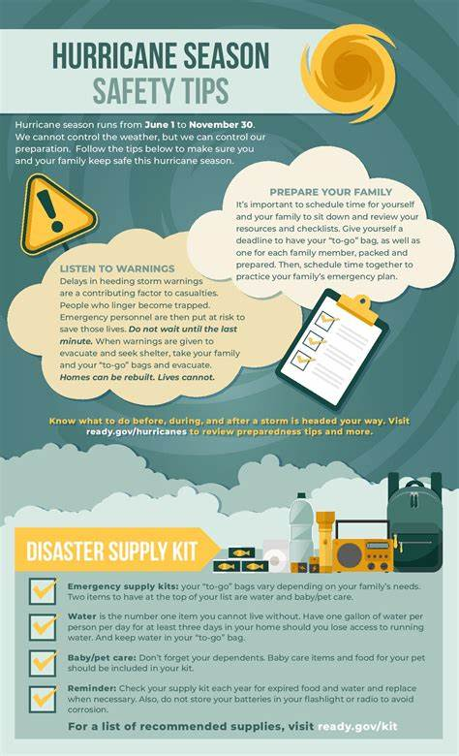
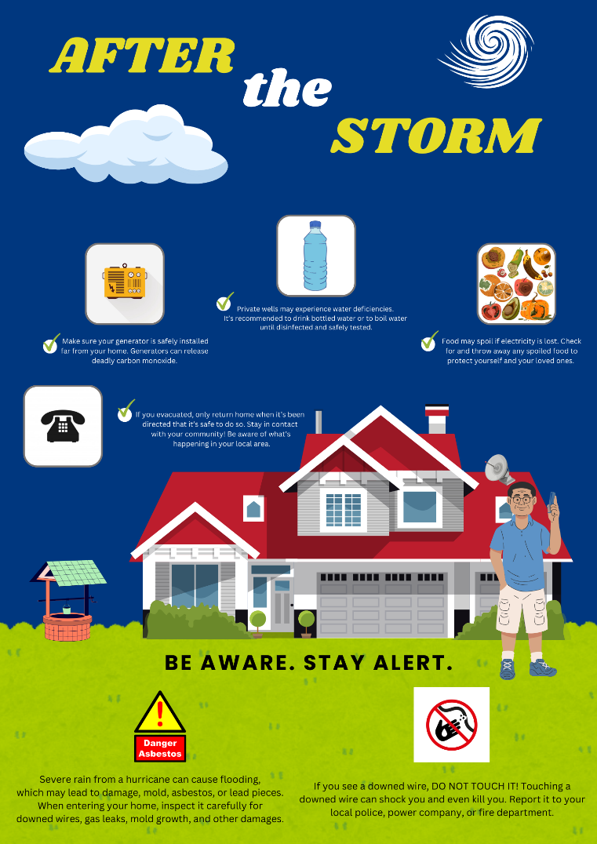
The following graphics can be used on their own (printed) or posted on local public health webpages, and linked to via social media posts:
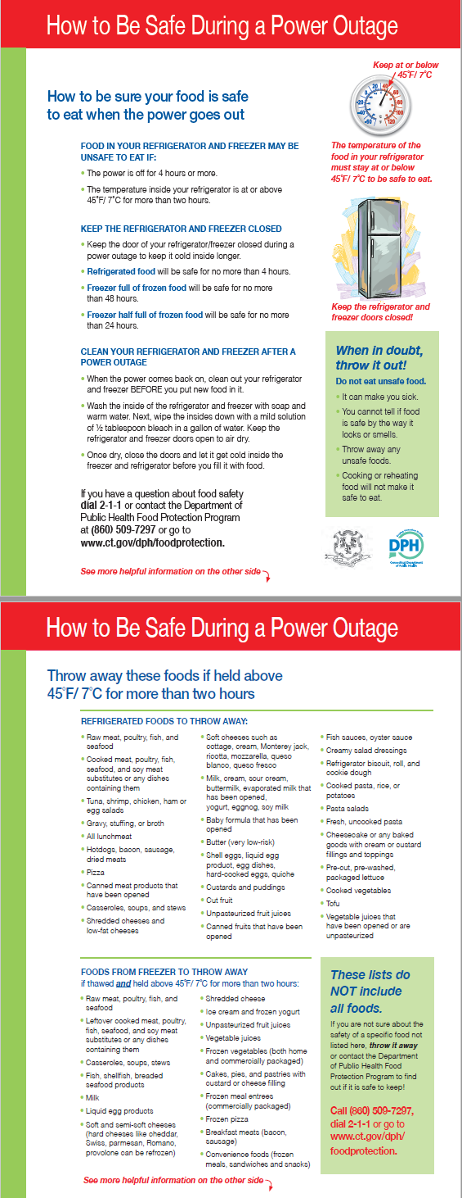
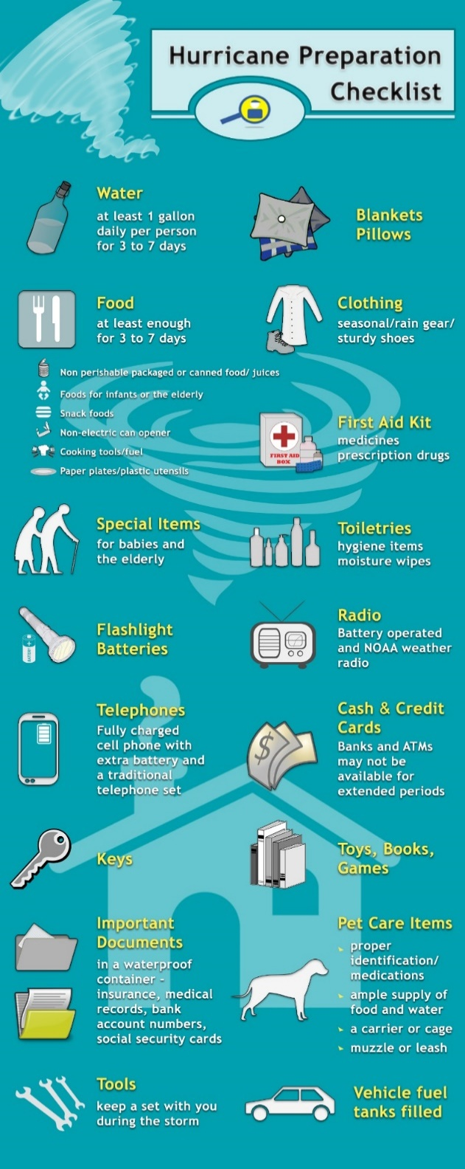
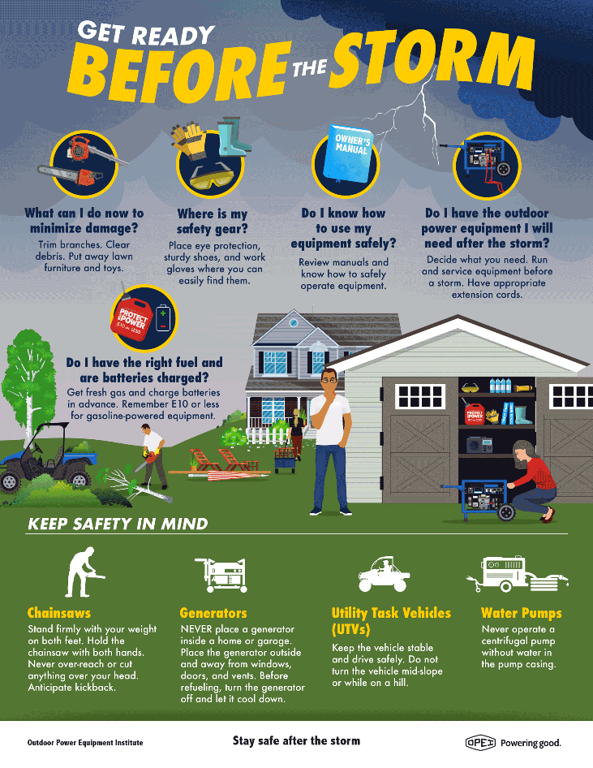
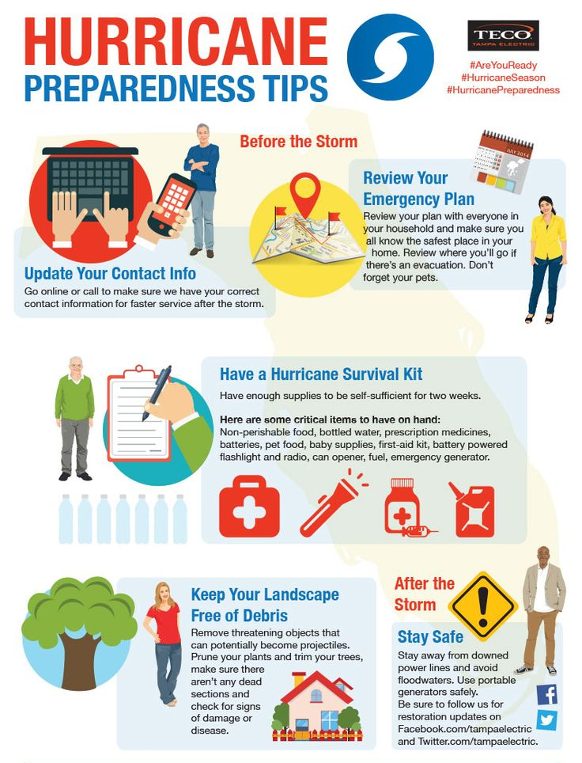
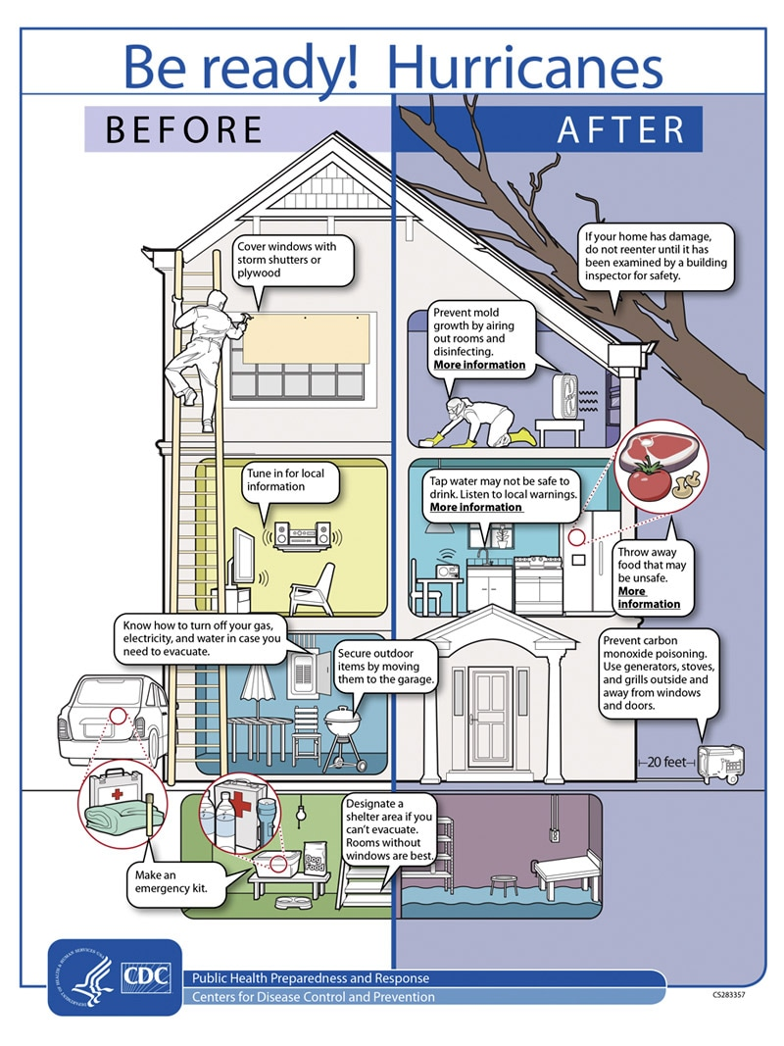
Insert logo

Web Content

Hurricane Safety for Access and Functional Need Populations

Hurricanes can pose severe health risks, particularly for those with mobility issues such as children, older adults, and individuals reliant on medical devices. People with access and needs limitations are especially vulnerable due to factors like difficulty accessing safe environments, dependence on electricity for medical devices, and limited means to stay hydrated or access medication. Understanding how to mitigate these risks with common-sense practices and additional tips can help protect these at-risk groups during hurricanes.

General Tips for Hurricane Safety
Stay Home:
- Keep updated with local news and weather reports
- Secure windows, doors, and outdoor items
- Have an emergency kit ready with essentials, including drinking water
- Know your evacuation routes
- Identify the nearest shelters.
Stay Hydrated:
- Drink plenty of water, even before feeling thirsty
- Have a supply of bottled water available
- Follow boil water advisories if issued
- Be aware of potential disruptions to the drinking water system and adhere to guidelines from local authorities.
Key Recommendations for Vulnerable Populations
- If you are on dialysis, reach out to your dialysis center to set up appointments prior to and immediately after the storm, so that your treatments are only minimally interrupted. Knowing the location of more than one facility is beneficial.
- If you use medical equipment in your home that requires electricity, talk to your doctor or health care provider about what you may be able to do to keep it running during a power outage.
- An emergency can make it difficult for you to refill your prescription or to find an open pharmacy. Organize and protect your prescriptions, over-the-counter drugs, and vitamins to prepare for an emergency.
- Plan ahead for accessible transportation that you may need for evacuation or getting around during or after disaster. Check with local transit providers as well as with your local heath department to find accessible options.
- Plan for children and adults who may have difficulty in unfamiliar or chaotic environments. Consider your service or support animal or pets and plan for food, water and supplies. If you need to evacuate, you’ll need to know whether your shelter allows pets or not, since some shelters only allow service or support animals.
For more information on preparing vulnerable populations, visit the DPH webpage at: Access and Functional Needs

Hurricane Events: Stay Safe and Prepared
Hurricanes can severely impact the environment, which in turn can have a negative effect on our health. Understanding the risks and how to protect yourself during a hurricane is crucial.
Before a Hurricane
- Have a Plan: Have a plan for your family and property! Use the CT Guide to Emergency Preparedness to develop a plan.
- Emergency Kit: Your kit should include food, water, first aid supplies, battery-powered radio, flashlight, and other emergency supplies
- Check with Insurance: Homeowners insurance may cover flooding during a hurricane. Take photos of your home and its contents.
During a Hurricane
- Evacuation Routes: Contact your local emergency management office or American Red Cross chapter and ask for the community hurricane preparedness plan. This plan should include information on the safest evacuation routes and nearby shelters
- Safe Room: Take refuge in a small interior room or closet on the lowest level away from windows or glass doors.
After a Hurricane
- Carbon Monoxide: Gasoline-powered generators release carbon monoxide (CO) which can be deadly. If your power goes out and you are using a gasoline-powered generator for energy, be sure that the generator is installed safely and far from your home
- Electrical Wires: If you see a downed wire, DO NOT TOUCH IT as it could shock you and even kill you. Report it to your local police, power company, or fire department
- Flooding/Private Wells: Severe rain during a hurricane could cause flooding which may cause structural damage, mold, and free asbestos or lead pieces. Enter your home carefully and inspect for any downed wires, gas leaks, mold growth, foundation cracks or any other damage.
- Food and Water: Food may spoil if there is a loss of electricity. Check for and throw away any spoiled food. Private wells may experience water quality deficiencies after flooding.

Key Recommendations
General Public
- Stay Prepared: Have an emergency kit, bottles of water and a plan for your home and family
- Stay Informed: Pay attention to hurricane advisories and warnings
- Seek Shelter: Locate your local shelter for emergency evacuations.
Vulnerable Populations
- Be Prepared: Know who to contact if your power goes out or if you need assistance with tasks. Keep a preparedness kit with extra medications, clean water and a flashlight.
- Stay informed: Know which local shelter has the appropriate accommodation if you need to evacuate
- Be Proactive: Don’t wait until the storm has arrived to decide! Take the warnings seriously and act on any necessary precautions or support that may be needed.
By following these guidelines and staying vigilant, you can protect yourself and your home from the dangers of hurricanes. For more detailed information, visit the Connecticut Department of Public Health Hurricane Page.

Fact Sheets

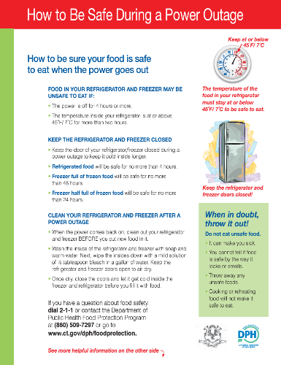
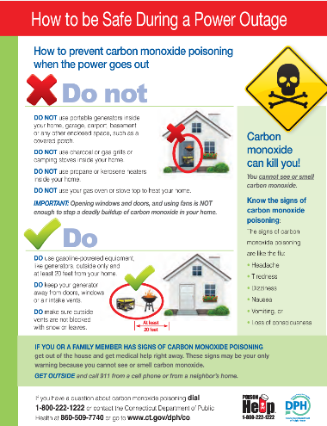
Power Outage: Food Safety:

For more information and fact sheets in multiple languages, visit: Weather (ct.gov)

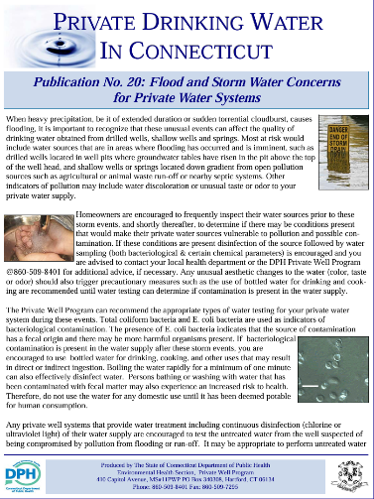
Flooding: Flooding/Private Wells:
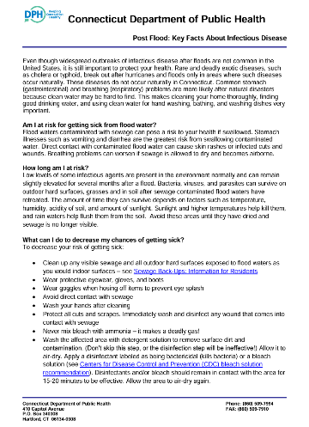

For more information, visit: Flooding Information for Homeowners About Private Wells Sewage and CleanUp (ct.gov)

Additional Resources
- CDC Hurricane Preparedness
  - Preparing for Hurricanes or Other Tropical Storms | Hurricanes | CDC
  - Preparedness and Safety Messaging for Hurricanes
- National Hurricane Center
  - National Hurricane Center (noaa.gov)
- Ready.gov
  - Hurricanes | Ready.gov
- DESPP
  - Know Your Zone-Evacuation Maps
  - Resources for the Deaf and Hard of Hearing
  - Summer Weather in Connecticut
  - Sea, Lake, and Overland Surge from Hurricanes maps (SLOSH maps):
  - Fema guide for alerts and warnings
- CT DPH Hurricane Page
  - Hurricanes (ct.gov)
  - Natural Disasters - Hurricanes (ct.gov)
  - Weather Information
    - Heat
    - Carbon Monoxide
    - Power Outage
    - Flooding/Private Wells
- CT Guide to Emergency Preparedness
  - preparedness12pgpdf.pdf (ct.gov)

Available in the following languages:
- Chinese
- English
- French
- Italian
- Kreyol
- Polish
- Portuguese
- Russian
- Spanish
- Vietnamese

