10th Annual CT Secondary Transition Symposium

Empowering Pathways:

Navigating Adulthood with Confidence

Tuesday, March 25, 2025 | 9:00 a.m. – 2:00 p.m.

Central Connecticut State University

The Connecticut Secondary Transition Symposium brings students and their families together with educators and other professionals to improve secondary transition programming and services for students with disabilities.
Our Keynote speakers will be George (“Big G”) and Corrina Manesiotis, owners of Big G’s Cookies in Trumbull, CT. George discovered his love of baking when he took a bake shop class while a student at Trumbull High School. His mother, Corinna, has supported the idea from its inception. Together, the mother-and-son team spent two years developing their own recipes, including a secret ingredient.

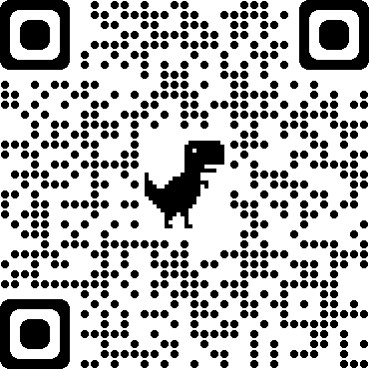

All participants must register through Canvas* to gain access to the symposium materials. Instructions for Canvas will be sent within the registration confirmation notice.
There is a $15 registration fee. Students/Youth are FREE (cost to be covered by CT State Department of Education).
Registration is available on the SERC Events page found at https://ctserc.org/events (or scan QR code provided here).
*Canvas is the Learning Management System where our Symposium’s materials and activities will take place.
